**SRES’s**

**SANJIVANI COLLEGE OF**

**ENGINNERING,**

**KOPARGAON – 423603(M.S.)**



**Department of**

**Electronics & Telecommunication Engineering**

**2018-2019**

**GROUP NO : 05**

**PROJECT ON**

**“DESIGN & IMPLEMENT ONE KW CAPACITY SINGLE PHASE GRID TIE SOLAR INVERTER”**

**Field of Specialization:**

Power Electronics

**Project Definition:**

Now we are living in a modern age where almost everything is run by Electrical Energy. For greater industrialization and population growth the Energy demand rate is now increasing day by day. In International Energy Outlook 2009 by the U.S Energy Information Administration, predicted that the rate of generation of global electricity will be increased to 23.2 trillion kWh in 2015, and for the next five years it will increase to 31.8 trillion kWh. The conventional electricity generation by burning fossil fuels like coal, gas, oil is unable to meet up this rapidly increasing electricity demand.

The reason is that these fossil fuels are treated as natural resources whose amount is very much limited and is decreasing day by day. On the other side burning the fossil fuel emits toxic gas like carbon dioxide which is harmful for our health and environment.

The economically and environmentally suitable solution to fulfil the energy demand is the Renewable Energy.Among all forms of Renewable Energy such as solar energy, wind energy, biomass energy, tidal energy, energy from the rice husk, the popularity of solar energy is

increasing. To fulfil the Energy demand and to ensure proper utilization of Energy, the photovoltaic inverter is a good solution. The word “Photovoltaic” means converting light energy to electrical energy. For getting electrical energy from the solar energy, the PV (Photovoltaic) module is used.

The energy produced in this way is DC power. But to convert the DC power to AC power, Inverters are used. There are two types of inverters. One is stand-alone and the other type is grid-connected. Stand-alone inverter is mainly used in rural areas or in those areas where the electricity is not available. Large capacity batteries are used for storing the energy produced by the solar panel. On the other hand the grid connected inverter is installed in that type of areas where the grid is available and is able to accept the energy from the photovoltaic system.

Grid connected inverter converts the DC power into that type of AC power whose voltage’s magnitude, phase and frequency is exactly same as the grid’s provided AC power. In this gird tie photovoltaic system the cost of PV module plays an important part.

According to the survey report presented by the IEA-PVPS, in 2011 the average price per watt of PV module was 1.38 USD. In 2012 the average price per watt of PV module was reduced to 1.16 USD, which indicates the reduction cost is about 15.9%. In some countries, at the end of the year 2012 the average price per watt of PV module went below 0.6 USD. Due to the decreasing price of PV modules, availability of sun shine, no cost for fuel, low maintenance cost, reliability, providing noise and pollution free environment in 2010 above 78% of world market was for that type of applications which are related with Grid Connected Photovoltaic Inverter system.

**ABSTRACT:-**

This Project is aimed to present the design and implementation of a one kilowatt capacity single phase grid tie photovoltaic inverter. The proposed design and simulation process of this system is in PSIM simulation environment. The reason for choosing the software PSIM is that it provides the solar module facilities.

For single phase grid tie inverter design some special types of consideration, like reference voltage creation to synchronize the inverter’s output with grid, PWM (Pulse Width Modulation) signal creation by comparing the reference and triangular wave, is designed and simulated precisely.

**Objectives:**

* The Objectives of this project is to design an inverter that can be derived by 24V battery and can be used to operate AC loads while minimizing the conventional inverter cost and complexity using Microcontroller.
* The system’s main properties are:

1. Generation of a pure sine wave signal from a solar panel reducing the dependency on the fossil fuels and limited energy source .
2. Reduction of circuit’s complexity by using micro-controller to generate modulating signal.

**Scope:**

The main scope of our project is to production of quality electricity from a renewable source to reduce dependence on fossil fuels and the associated emissions of pollutants.

Our goal is to design and developed an inverter that will handle the task described.

**Block Diagram:**

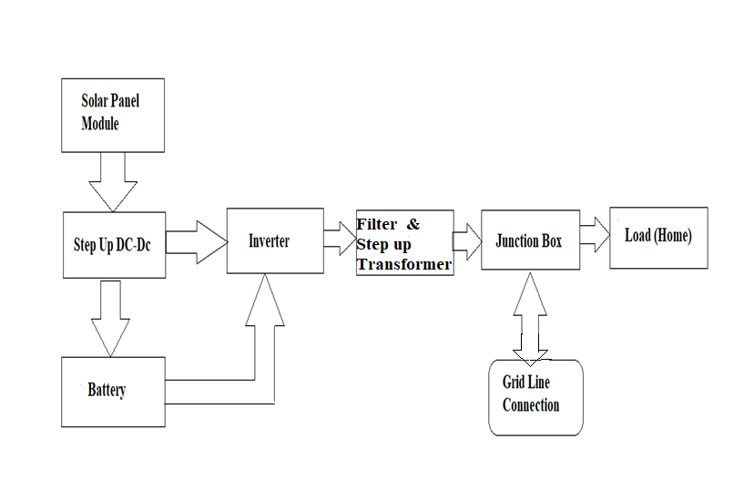

**Implementation:**

The aim of this system is to convert the DC input voltage which is collected from the solar panel, into the AC output voltage where the magnitude and frequency must be the same as the National Grid’s supply of AC voltage. It is shown in Figure that since the system is grid tie photovoltaic inverter, the grid’s provided sinusoidal voltage should be taken continuously as a reference signal while a triangular signal is also produced by the “Control & Gate drive circuit”. Here the triangular signal acts like carrier signal.

For single phase inverter four switching PWM signals is needed. “Control & Gate drive circuit” produces the four required switching PWM pulses by comparing the reference and carrier signal. Input voltage coming from solar panel according to the four switching PWM pulses. After switching, the inverter’s output voltage frequency is higher than the required frequency level, so it needs filtering. So if the output voltage level of the inverter is lower than the grid’s provided voltage level, isolation transformer will step up the inverter’s output voltage and then will give power to the grid. In this way it is possible to keep the inverter’s output AC voltage level fixed.

|  |  |  |  |
| --- | --- | --- | --- |
| **Sr.**  **No.** | **Name of Students** | **Exam Seat No.** | **Signature** |
| **01** | **Bhagwat Poonam Sanjay** |  |  |
| **02** | **Bhange Prafullkumar Kailas** |  |  |
| **03** | **Avhale Amol Shivnath** |  |  |
| **04** | **Bavche Rupali Arun** |  |  |
|  | **Project Guide:- Prof. P.S. Kurhe** | | |